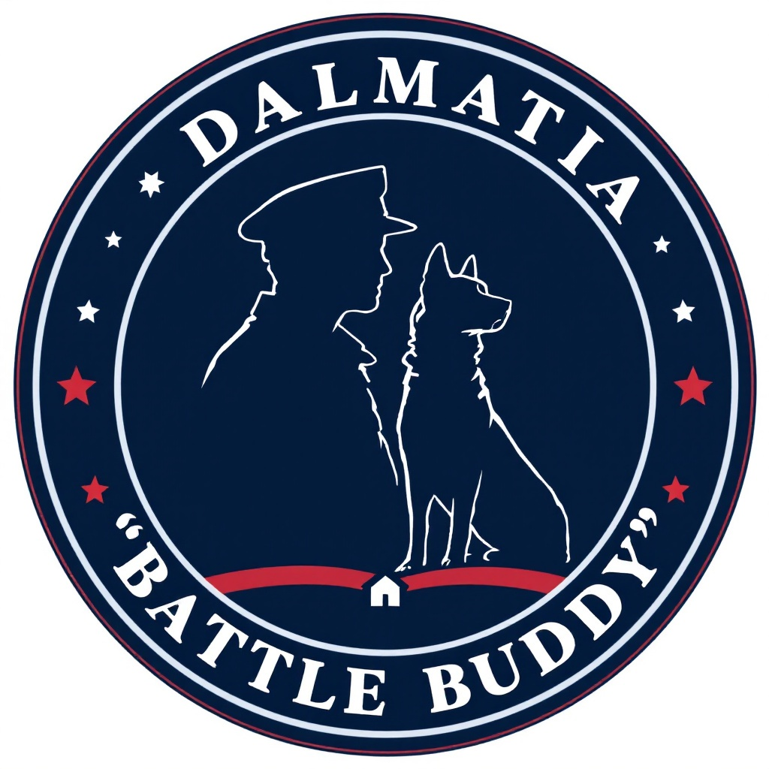
DALMATIA BNB BATTLE BUDDY PROGRAM
Veteran Application Form
Complete this form and email it to Owner@DalmatiaBnB
Use the Subject Line “Battle Buddy”
APPLICANT INFORMATION
Full Name: _________________________________
Military Branch: ____________________________
Years of Service: ___________________________
Discharge Status: __________________________
VA Disability Rating (if applicable): ________
CONTACT INFORMATION
Address: __________________________________
City/State/ZIP: ___________________________
Phone: ___________________________________
Email: ___________________________________
Preferred Contact Method: □ Phone □ Email
DISABILITY INFORMATION
Primary Disability: _________________________
Secondary Disabilities (if applicable): _______
Mobility Aids Used: ________________________
Living Situation: □ House □ Apartment □ Other
SERVICE DOG NEEDS
Types of Tasks Needed (check all that apply):
□ Mobility Support
□ PTSD Support
□ Medical Alert
□ Retrieval Tasks
□ Balance/Stability
□ Other (please specify): ___________________
Please describe how a service dog would help with your daily activities:
_________________________________________
_________________________________________
LIVING ENVIRONMENT
Do you: □ Own □ Rent
If renting, do you have landlord approval? □ Yes □ No
Other people in household: _________________
Other pets in home: ______________________
FINANCIAL RESPONSIBILITY
Estimated Monthly Expenses:
- Food: $50-100
- Veterinary Care: $30-50 (wellness plan)
- Grooming: $40-60
- Emergency Fund: Recommended $1000-2000 savings
- Insurance: $30-50 monthly
Can you financially commit to:
Regular veterinary care? □ Yes □ No
Monthly food and supplies? □ Yes □ No
Emergency medical expenses? □ Yes □ No
Professional grooming as needed? □ Yes □ No
Do you have a plan for unexpected medical expenses? □ Yes □ No
If yes, please specify: _____________________
COMMITMENT UNDERSTANDING
Our program requires:
- 6-week intensive training program ($4,800)
- Daily practice sessions
- Regular follow-up appointments
- Proper care and maintenance of the dog
- Adherence to service dog public access guidelines
Can you commit to these requirements? □ Yes □ No
REFERENCES
Please provide two personal references:
1. Name: _________________________________
Relationship: __________________________
Phone: ________________________________
2. Name: _________________________________
Relationship: __________________________
Phone: ________________________________
ADDITIONAL INFORMATION
Please share any additional information that would help us understand your needs:
_________________________________________
_________________________________________
CERTIFICATION
I certify that the information provided in this application is true and complete to the best of my knowledge. I understand that I will be financially responsible for all aspects of the service dog's care after completion of training.
Signature: _______________________________
Date: __________________________________
Submit completed applications to:
Dalmatia BnB
Email: owner@dalmatiabnb.org
Phone: 660-890-5766
For Office Use Only:
Date Received: ___________________________
Application Status: _______________________
Notes: _________________________________

